Precision in Processing Data from

Heterogeneous Resources

Gio Wiederhold

Stanford University, March 2000

"The certitude that any book exists on the shelves of the library first led to elation, but soon the realization that it was unlikely to be found converted the feelings to a great depression”, Luis Borges: The Infinite Library, 1964.

Abstract
Much information is becoming available on the world-wide-web, on Intranets, and on publicly accessible databases. The benefits of integrating related data from distinct sources are great, since it allows the discovery or validation of relationships among events and trends in many areas of science and commerce. But most sources are established autonomously, and hence are heterogeneous in form and content. Resolution of heterogeneity of form has been an exciting research topic for many years now. We can access information from diverse computers, alternate data representations, varied operating systems, multiple database models, and deal with a variety of transmission protocols. But progress in these areas is raising a new problem: semantic heterogeneity.
Semantic heterogeneity comes about because the meaning of words depends on context, and autonomous sources are developed and maintained within their own contexts. Types of semantic heterogeneity include spelling variations, use of synonyms, and the use of identically spelled words to refer to different objects. The effect of semantic heterogeneity is not only failure to find desired material, but also lack of precision in selection, aggregation, comparison, etc., when trying to integrate information. While browsing we may complain of `information overload'. But when trying to automate these processes, an essential aspect of business-oriented operations, the imprecision due to semantic heterogeneity can be become fatal.
Manual resolutions to the problem do work today, but it forces businesses to limit the scope of their partnering. In expanding supply chains and globalized commerce we have to deal in many more contexts, but cannot afford manual, case-by-case resolution. In business we become efficient by rapidly carrying out processes on regular schedules. XML is touted as the new universal medium for electronic commerce, but the meaning of the tags identifying data fields remains context dependent.
Attempting a global resolution of the semantic mismatch is futile. The number of participants it immense, growing, and dynamic. Terminology changes, and must be able to change as our knowledge grows. Using precise, finely differentiated terms and abbreviations is important for efficiency within a domain, but frustrating to outsiders. In this paper we indicate research directions to resolve inconsistencies incrementally, so that we maybe able to interoperate effectively in the presence of inter-domain inconsistencies. This work is an early stage, and will provide research opportunities for a range of disciplines, including databases, artificial intelligence, and formal linguistics. We also sketch an information systems architecture which is suitable for such services an their infrastructure. Research issues in managing complexity of multiple services arise here as well.
The conclusion of this paper can be summarized as stating that today, and in even more in the future, precision and relevance will be more valuable than completeness and recall. Solutions are best composed from many small-scale efforts rather than by overbearing attempts at standardization. This observation will, in turn, affect research directions in information sciences.

1. Introduction
A study by Inktomi and NEC Research Institute showed that the Internet at the end of 1999 provided access to at least one billion unique indexable web pages [Inktomi:00]. Finding relevant information in such a massive collection is hard. Indexing here means that text from words that the pages contain can be extracted to direct its search engine. Inktomi performs automated searches as a service for Yahoo and its customers, while Yahoo itself uses human specialists to categorize a small, but high-value portion of the web. This cooperation between automation and expert inputs provides a direction for improving Internet-based information systems.
1.1 Getting information rather than data. We define information, following tradition, to be data that transmit something not known to the receiver, and that will cause the state of the world of the receiver to be altered [ShannonW:48]. The need for assistance in selecting actual information from the world-wide-web was recognized early in the web’s existence [BowmanEa:94]. A succession of search engines have provided rapid advances, and yet the users remain dissatisfied with the results [Hearst:97]. Complaints about `information overload’ abound. Most searches retrieve an excess of references, and getting a relevant result, as needed to solve some problem requires much subsequent effort in actual analysis of the content. And yet, in all that volume, there is no guarantee that the result is correct and complete.
Searches through specific databases can be complete and precise, since the contents of a database, say the list of students at a university, and their searchable attributes, as maintained by the registrar, is expected to be complete. Not obtaining, say, all the Physics students from a request, is seen as an error in precision, and receiving the names of any non-Physics student is an error of relevance.
When using the web for more complex queries than simple fact retrieval, we access multiple sources [ChangGP:96]. For purchasing or investment planning, comparison of alternatives is essential. The benefits of integrating related data from diverse sources may be even greater, since it allows the discovery or validation of relationships among events and trends in many areas of science and commerce.
1.2 Business needs. In this paper we consider professional needs, especially those that arise in business situations, other aspects are addressed in an earlier report [Wiederhold:99]. Business requirements include the need to get tasks done expeditiously. The need for repetitive human processing of obtained information should be minimal. These means that the information obtained should be highly reliable and relevant.
In manufacturing, for instance, the traditional needs are obtaining information about inventory and personnel, the best processes, equipment, and material to produce merchandise, and the markets that will use those goods. In distribution industries, the information needed encompasses the producers, the destinations, and the capabilities of internal and external transportation services. In these and other situations data from local and remote sources must be reliably integrated so they can be used for recurring business decisions.
The needs and issues that a business enterprise deals with include the same needs that an individual customer encounters, but place a higher value on precision. In business-to-business interaction automation is desired, so that repetitive tasks don’t have to be manually repeated and controlled [JelassiL:96]. Stock has to be reordered daily, fashion trends analyzed weekly, and displays changed monthly. However, here is where the rapid and uncontrolled growth of Internet capabilities shows the greatest lacunae, since changes occur continuously at the sites one may wish to access.
Modeling the business customers’ requirements effectively requires more than tracking recent web requests. First of all a customer in a given role has to be disassociated from all the other activities that an individual may participate in. We distinguish here customers, performing a specific role, and individuals, who will play several different roles at differing times. In a given role, complex tasks can be modeled using a hierarchical decomposition, with a structure that supports the divide-and-conquer paradigm that is basic to all problem-solving tasks [W97:M].

2. Problems in Integration of Information
The major problem facing all types of users is the ubiquity and diversity of information. Finding the right information takes time, effort, and often luck. Just as the daily newspaper presents an overload of choices for the consumer in its advertising section, the world-wide web contains more alternatives than can be investigated in depth. When leafing through advertisements the selection is based on the organization of the presentation, the prominence of the advertisement, the advertised price, the convenience of getting to the advertised merchandise in one’s neighborhood, the reputation of quality, personal or created by marketing, of the vendor, and unusual attractive features. The dominating factor differs based on the merchandise, commodity goods being more distinguished by price, and piece goods more by quality attributes. Similar factors apply to online purchasing of merchandise and services. Lacking the convenience of leafing through the newspaper, greater dependence for selection is based on selection tools.
2.1 Getting complete information. Getting all of the possibly relevant, the complete information, is a question of breadth. In bibliographic settings completeness of coverage is termed `recall’. The indexes used for automated searching depend on words, but the usage of words throughout the web is inconsistent. If relevant goods or services are described with unexpected terms their information will not be recalled. Conversely, when words have multiple interpretations, depending on context, excess information will be produced, resulting in loss of precision, or relevance.
To improve completeness a number of methods have been employed to widen the search beyond direct matches. Most depend on thesauri, which expand the search term with similar terms, terms used for its subsidiary concepts, and perhaps even terms that are generalizations of the search term. A well-known example is the Unified Medical Language System (UMLS), which aggregates terms from several medical subdomains, as patient’s problem lists, diagnostics, pathology, and bibliographic categorizations to increase recall when perusing the medical literature [HumphreysL:93]. However, any broadening is likely to lead to loss of precision, since irrelevant citations will now be collected and reported as well. Figure 1 sketches the relationship among these parameters. The curvature of the precision and recall metrics indicate the effectiveness of the methods used.

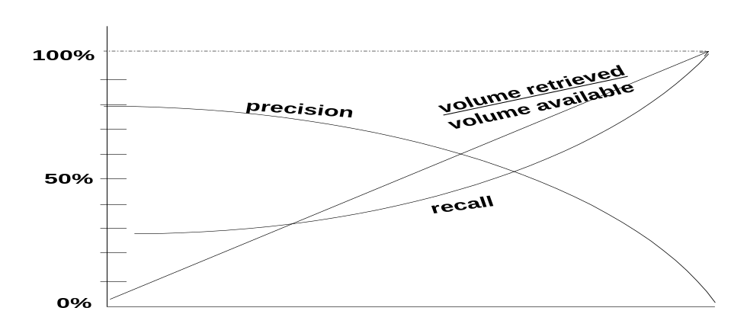
Figure1. Typical relationships between data volume retrieved, recall, and precision.

Unfortunately, poor relevance causes a loss of actual recall. If the increase of citations or other data is significant, the required effort which has to process and analyze good and bad citations is likely to be so great that human researchers will give up, and ignore potentially useful information. We all have had this experience when web-browsing. In the world of statistics the amount of irrelevant information retrieved is termed `false positives’. Even a small fraction of false positives can be devastating, since to distinguish true and false positives requires follow-up. The cost of follow-up is always relatively high when compared to search, since it involves human jusdgement. Minimal follow-up means retrieving more complete information, checking the contents, and deciding on actual relevance. For instance, if we deal with 100 000’s of instances, a 1% false positive rate means following up on 1000 false leads, easily overwhelming our capabilities.
2.2 Consistency is local. Precision in on-line commerce requires a consistent structure and a consistent terminology, so that one term always refers to the same set of objects. For example when we talk about equipment for a `sports-car’ both partners in a business transaction want to refer to exactly the same set of vehicles. But no law or regulation can be imposed on all suppliers in the world that define what a sports-car is. Consistency is a local phenomenon. There might be a professional society, say a sports-car club, which will define the term for its membership, and not allow in its annual show a convertible without a roll bar to be entered. A manufacturer may sell the same type of car as a sports car after installing a stiffer suspension and a nice paint job. Within a closeknit group the terms used are well understood because they refer to real objects in our neighborhood or are abstractions built from other known terms [RoyH:97].
Terms, and their relationships, as abstraction, subsets, refinements, etc. are hence specific to their contexts. We denote the set of terms and their relationships, following current usage in Artificial Intelligence, as an ontology [WG:97]. Many ontologies have existed for a long time without having used the name. Schemas, as used in databases, are simple, locally consistent ontologies. Foreign keys relating table headings in database schemas imply structural relationships [Chen:76]. Included in ontologies are the values that variables can assume; of particular significance are codes for enumerated values used in data-processing [McEwen:74]. For instance, names of states, counties, suppliers, etc., are routinely encoded to enhance consistency. When such terms are used in a database the values in a schema column are constrained, providing another level of a structural relationship.
There are thousands of local, corporate, or organizational ontologies, often maintained by domain specialists. Today many ontologies are being created within DTD definitions for the eXtended Markup Language (XML) [Connolly:97]. Large ontologies have been collected with the objective to assist in common-sense reasoning (CyC) [LenatG:90]. However, large ontologies, collected from diverse sources or constructed by multiple individuals over a long time, will contain substantial inconsistencies. In these efforts the objective is again to increase breadth or recall, rather than precision or relevance.
Many ontologies have textual definitions for their entries, just as found in printed glossaries. These definitions will help human readers, but cannot guarantee precise semantic matching of entries outside of their contexts, because the terms used in the definitions also come from their own source domains.
Experimental communication languages that specify the ontology to be used, as KQML [LabrouF:94] and OML [Kent:99], provide a means to clarify message contexts, but have not yet been used in practical situations.
2.3 Inconsistency. Inconsistency of among distinct sources is due to their autonomy, which allows and even encourages heterogeneity. Inconsistency among heterogeneous sources has many facets, by technical progress has removed has overcome most mechanical issues. We can access data independent of location, computer hardware, operating systems, programming language, and even data representations. Not well handled today is the inconsistency of semantics among sources. The problem with matching terms from diverse sources is not just that of synonyms – two words for the same object, say lorry and truck -- or one word for completely different objects, as miter in carpentry and in religion. Many inconsistencies are much more complex, and include overlapping classes, subsets, partial supersets, and the like.
Languages exist in working contexts, and local efficiency determines the granularity and scope of word usage. Few terms refer to instances of real-world object instances, say Exeter cathedral, most terms refer to abstract groupings, and here different interpretations abound. The term ‘vehicle’ is different for architects, when designing garage space, from that of traffic regulators, dealing with right-of-way rules at intersections. The term vehicle is used differently in the transportation code than in the building code, although over 90% of the instances are the same. A vendor site oriented towards carpenters will use very specific terms, say sinkers and brads, to denote certain types of nails, but those terms will not be familiar to the general population. A site oriented to homeowners will just use the general category of nails, and may then describe the diameter, length, type of head, and material.
Avoiding inconsistency by enforcing consistency seems attractive, but fails for several reasons. First of all, we see that each source develops is language in its own context, and uses terms and classifications that are natural and efficient to its creators and owners. The homeowner cannot afford to learn the thousands of specialized terms needed to maintain one’s house, and the carpenter cannot afford wasting time by circumscribing each nail, screw, and tool with precise attributes.
Attempting to maintain consistency just among interacting domains is not a viable approach because of scale and dynamics. Carpenters interact with hardware, lumber, and tool suppliers as well as homeowners, and the same suppliers interact with businesses, who in turn interact with shippers, and airlines, etc. In the end global consistency would be required. However, global consistency would take a very long time to achieve, and during that time new terms and relationships will make earlier ontological agreements obsolete.
2.4 Recognizing inconsistency. When dealing with disjoint groups the meaning of terms can differ arbitrarily. To be safe we should make the default assumption that no terms will match unless specific arrangements have been made. Most insidious are cases when terms in closely related contexts differ slightly. Then the differences may not be easily observed, and only when computations give erroneous results will the misunderstandings be discovered. An example of such a semantic difference is the use of the term employee, which in payroll system includes all persons being paid, and in a personnel system includes all people available to do work. In a realistic and large organizations there are nearly always some people that do not fall into both categories: staff taking early retirement, employees on loan to outside projects, specialists on consulting contracts, etc. Hence, the differences found are rational, since the departments had to satisfy different objectives: check generation and tracking of work and space assignments
Intranets, operating within one enterprise, should have a fairly consistent ontology. However, as the employee example showed, it’s best to check all assumptions. Aberrations can easily be demonstrated in by computing the differences of the membership from their respective databases. If ignored, computations based on their match will be wrong. Within a specific business domain the contexts must be clear and the ontology unambiguous. Once the rules are known, integration can be made precise and unambiguous [ElMasriW:79]. When access to information becomes world-wide, and contexts become unclear, imprecision results, making business transactions unreliable. In large multi-national corporations and companies that have grown through mergers, differences are bound to exist. These can be dealt with if the problems are formally recognized, but often they are isolated, and solved over and over in an ad-hoc fashion.
2.4 Improving recall. To achieve a high recall all possibly relevant sources should be accessed. On the Interner that number is open-ended. A number of worm programs scan the web continuously, scanning pages as input to their indexing schemes. Terms for deemed useful for subsequent retrieval and links to further pages are collected. The effort to index all publicly available information is immense. Comprehensive indexing is limited due to the size of the web itself, the rate of change of updates to the information on the web, and the variety of media used for representing information [PonceleonSAPD:98]. To keep abreast of changes sites that appear to change frequently will be visited by the worms more often, so that the average information is as little out of date as feasible [Lynch:97]. However for sites that change very rapidly, as news broadcasts, creating indexes is nearly futile. Some services cache retrieved pages, so that the data, even though obsolete, remains available.
Automatic indexing systems focus on the ASCII text presented on web pages, primarily in HTML format. Documents stored in proprietary formats, as Microsoft Word, Powerpoint, Wordperfect, Postscript, and Portable Document Format (PDF) [Adobe:99] are ignored today. Valuable information is often presented in tabular form, where relationships are represented by relative position. Such representations are hard to parse by search engines, although specialized tools have been developed for that purpose in the past.
Also generally inaccessible for search are images, including icons and corporate logos, diagrams and images [Stix:97]. Some of these images contain crucial embedded text; if deemed important, such text can be extracted [WangWL:98]. Several specialized vendors and museums provide large image libraries on-line, and for them the quality of retrieval depends wholly on ancillary descriptive information [DeYoung:00]. Iterative refinement then can employ feature search on content parameters as color or texture [Amico:98], but purely content-based methods are typically inadequate for initial selection form large libraries. There are also valuable terms for selection in speech, both standalone and as part of video representations [PonceleonSAPD:98]. The practice of video-clip indexing, supported by broadcasters, is relatively mature [MPEG:00]. Its problems have been addressed by brute force, using heavyweight indexing engines and smart indexing engines combining speech, voice prints, and closed captioning for the hard-of-hearing, when available.
Web sites that derive their information from databases will only provide access to selected metadata, and not to their actual contents. How well those meta-data represent its actual contents depends on the effort and competence of the database owners. Some prefer not to be visited by worms at all, preferring that customers find them directly, while some seek maximum exposure. HTML pages can contain a header forbidding access to worms. On the other hand some web sites try to fool the search engines, by including excessive and even false meta-information, hoping to generate more visits to their web-sites.
The consumer of information will typically find it too costly to produce indexes for their own use only. Schemes requiring cooperation of the sources have been proposed [GravanoGT:94]. Since producing an ontology is a valued-added service, it is best handled by independent companies, who can distinguish themselves by comprehensiveness versus specialization, currency, convenience of use, and cost. Those companies can also use tools that break through access barriers in order to better serve their population. For scientific objectives there is a role here for professional societies [ACM:99], since these communities are not likely to be well served by commercial interests.

3. Articulation
Inconsistent use of terms makes simplistic sharing of information based on term matching from multiple sources incomplete and imprecise. The problems due to inconsistency are more of a hindrance to business than to individuals, who deal more often with single queries and instances. In business similar tasks as purchasing and shipping occur regularly, and should be automated. Luckily, interoperation of source domains in businesses is limited and constrained to specific applications. In our approach to dealing with semantic heterogeneity we focus on the intersection of domains that related by common application use. We define an articulation to manage that intersection.
A domain is defined as having a consistent internal ontology. If there is an explicit ontology, and that ontology has been enforced, the task of defining the domain is simplified. In practice we often start with database schemas. An entity-relationship model used for design can provide important relationships among the tables. Constraints on table values, often documented as lists or look-up tables can augment the domain ontology further.
3.1 Defining an articulation. For integration of information we will have two or more domains with their ontologies. Traditional database integration mandated that complete schemas be considered, but a business application needs only to consider terms used for matching specific data. For instance, in purchasing, only the objects to be purchased need to be matched, together with those attributes that play a role in selecting objects for purchase, as size, various specifications, and price. Personnel and manufacturing data can be ignored. Defining the articulation can still involve much work, and typically involves human expertise, but once the matching rules are established the actual purchase transactions can be automated. The concept is illustrated in Figure 2.
Rules for articulation can be as simple as equating obvious terms: shoe_{s} in the shoe store equals shoe_{f} in the shoe factory, define tabular matches as color_{s} := colorfunction(color_{f} ), or can have conditionals, say, size_{s} if location_{f} = `Europe’ :=size_{f} , else := sizefunction( size_{f}). We see that the definition of a top-level articulation often requires subsidiary definition, for instance Europe will probably require a table of countries using metric shoe sizes. A general definition of Europe from a global geographic ontology is likely to be wrong in the shoe-purchasing articulation. Mismatches are rife when dealing with geographic information, although localities are a prime criterion for articulation [MarkMM:99]. For instance, maps prepared for property assessment will use different identifiers and boundaries than the terms used in giving driving directions. When the directions prove inadequate, say because of a road closure, an appropriate map is needed to allow matching points to be found.
3.2 Maintaining articulations. An articulation creates a new, limited ontology, sufficient only for making the required linkages to the source ontologies for a particular application. Many such ontologies will be needed as the number of applications requiring access to multiple sources increases. The limited scope and independence of application-specific articulated ontologies simplifies their individual maintenance. Having a formal articulation permits computer systems to automate work performed today by many humans, performing a variety of brokering services. The benefit will be a significant increase in the speed of setting up multi-domain, business-to-business transactions.
When humans perform articulation, either on the phone or in direct interaction on the Internet, the problems of semantic mismatch are less obvious. After automation the role of the humans becomes creation and maintenance of the articulation rules. Logical organizations to be responsible for broader articulation ontologies would be societies serving brokering industries, as say the National Drug Distributors Association (NDDA) in the USA.
Most of those individuals or organizations will not be sophisticated users of computing, so that tools will have to be developed for the collection and maintenance of articulation rules [JanninkSVW:98]. The articulations in turn will be embedded as mediating nodes in our information systems, as discussed in Section 4.
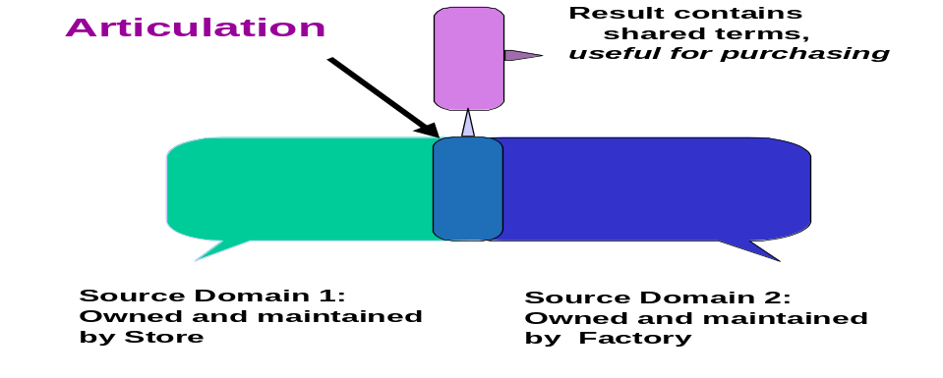
Figure 2. Sketch of an articulation

3.3 Multiple articulations. Multiple articulations among identical domains are likely to be needed as well. Medical findings of interest to a pathologist will be confusing to patients, and advice for patients about a disease should be redundant to the medical specialist. Some partitioning for distinct application roles within single sources exists now; for instance, Medline has multiple access points [Cimino:96]. It is unclear if the sources are the best judges of their own relevance, or of such assessments are best left to outside experts. When there multiple sources there is certainly a role for mediating modules to interpret meta-information associated with source sites and use that information to filter or rank the data obtained from those sites [Langer:98]. Doing so requires understanding the background and typical intent of the customer and the application. Note that the same individual can have multiple customer roles, as a private person or as a professional; we revisit that issue in Section 4.5.
3.4 Combining articulations. There will be many applications that cannot live within a single articulated ontology. For example logistics, which must deal with shipping merchandise via a variety of carriers: truck, rail, ship, and air, requires interoperation among diverse domains, as well as among multiple companies located in different countries. To resolve these issues we have proposed an ontology algebra, which uses rules to resolve differences in the intersection of base ontologies [MitraWK:00]. Having an algebra promises to provide a basis for scalability and optimization. A capability for arbitrary composition removes pressure to create large source ontologies or even large articulations, keeping maintenance local. Large compositions may have multiple evaluation paths, and optimizers can make choices that are efficient, since the sizes of intermediate results, and their access costs may vary greatly.

3.5 An Example: Dealing with bioinformatics computations. Precision becomes crucial when the data quantities become large. For instance, in bioinformatics applucations deal with the 3 billion base pairs of the human genome, and shorter, but still massive strands from other species. To exploit this data for diagnostics and therapeutics we must match abnormalities to about 10 000 protein-coding regions and their disease-causing variations. Genetic variations affect every single one of our 6 billion world population. At the same time, researchers in chemical genomics are generating systematically an increasing fraction of the few million small organic molecules. These molecules are candidates for pharmaceuticals that can switch protein generation or protein effectiveness on and off, affecting the several hundred metabolic pathways that control our six billion lives, and many more lives in future generations. The linkages are sketched in Figure 3.
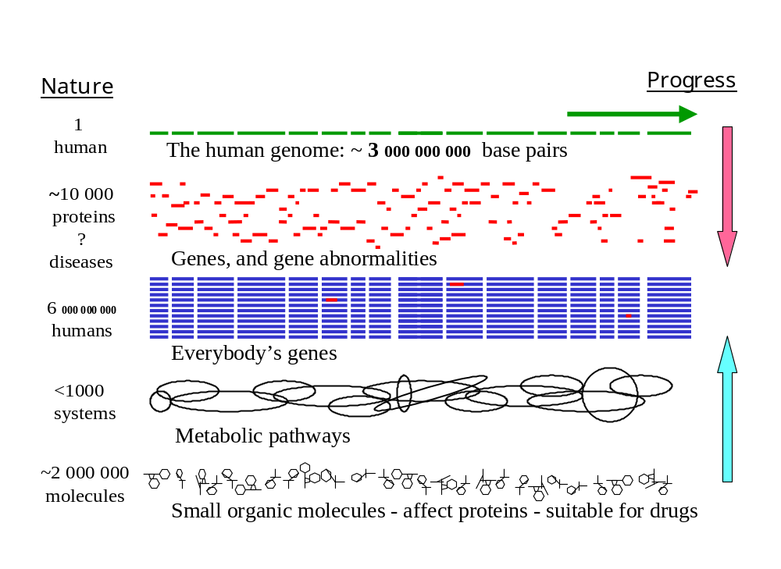Figure 3. Quantities of some potential data objects in bioinformatics
When navigating through this huge space for opportunities to develop drugs that can help specific subsets of mankind, we are faced with the dilemma of recall versus precision. Missing some potential effects due to poor recall is a loss of an unknown magnitude, but the cost associated with a false positive lead has a high cost that can be estimated, since the follow-up analyses are very resource intensive. Precision will be critical -- whenever we deal with 100 000’s of instances, even a 1% false positive rate means following up on 1000 false leads, easily overwhelming our research capabilities.

4. Architecture.
System designer make a distinction in distributed architectures between clients and severs, although the architecture of the web allows clients to be servers and vice versa without any constraints. There are active debates about the benefits of thin clients versus thin servers. The relative amount of fat in a node is due to the amount of services it provides, but we have argued above that we prefer to have small, domain specific sources, and then intermediate services, also of modest size, that can be composed to serve a wide variety of equally modest application clients. The outcome of that view is that we prefer information processing architectures to have three conceptual layers, where the middle layer is independent of the sources, but can exploit them, and serve as many clients as feasible, given application needs for domain simplicity, consistency and precision.
4.1 Middleware. So-called middleware provides the needed network linkages between clients and servers in a heterogeneous world. However, much of the existing commercial middleware provides little capabilities for information integration and even less for resolving semantic problems. Is simplicity, on the other hand, means that it can be installed without domain-specific expertise and be maintained by technical specialists.
However viewing the linkages as a strictly technical means to achieve binary interconnections ignores the added value provided now by human intermediaries. For travel planning we had travel agents, for logistics we had shipping agents, for publications filtering was performed by editors and librarians, and for supply-chains we relied on distributors. The cost and delays associated with human intermediaries causes these intermediaries to be bypassed in Internet-based technologies, since their operations are incommensurate with milli-second world-wide communications. Disintermediation causes a loss of services that increased precision when these people, selected, filtered, digested, integrated, and abstracted data for specific topics of interest [Resnick:97].
4.2 Agent technology. At the same time, there is an increased interest in agent technology, software which provides added value services for a client, as in locating resources and retrieving information [HuhnsS:97]. Agent software is intended to overcome the loss or the delays associated with human agents in moving to Internet-based commerce. Those agents must count on consistent meta data in order to carry out their tasks, but most agent literature does not define where the maintenance responsibilities lie. Often shared ontologies are assumed, that will bind sources, agents, and clients together [ChavezM:96 ]. Agents may count on middleware to resolve problems due to technical heterogeneity.
4.3 Mediators. Middleware, as well as agent technology deserves a well defined architectural niche. These services should be not attached to sources, since they may integrate multiple sources, nor to clients, since the required knowledge acquisition and and its maintenance only becomes economical when shared among multiple clients. Mediators are then services inside the web, while clients and sources will occupy the periphery and can remain of modest size [W:92].
To remain thin mediators should also be specialized. We discussed the need for partitioning of the tasks of semantic mismatch resolution in Section 2.2. That task however, while challenging, is just one of the tasks that needs to be performed at an intermediate level. Tasks performed by middleware, namely resolving technical heterogeneity and efficiently transporting data from servers to clients find a home in a mediated architecture. Tasks foreseen for agents, as locating, and validating sources find a home base in the mediating modules as well, even if their computational tasks extend over the network. Integration, improved by semantic mismatch resolution, is central to mediation. Reporting results to thin clients may involve summarization and abstraction to increase the value per data-unit transmitted. Such services become crucial for mobile clients, and we see already examples of such technologies attached to several servers [HadjiefthymiadesM:99].
The composition of synergistic functions grows a mediator into a substantial service. Such a service is best envisaged as a module within the networks that link customers and resources, as sketched in Figure 4. There is today a small number of companies building such mediators [W:98]. However, the technology is not yet suitable to be shrink-wrapped and requires substantial adaptation to individual settings. 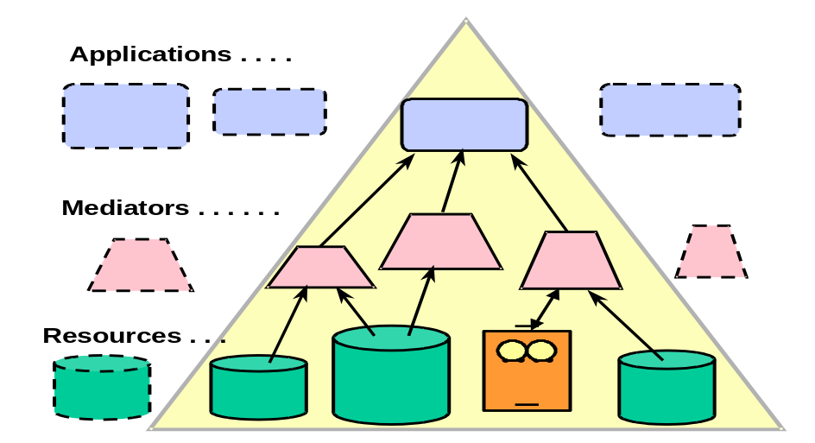

Figure 4. An application instance composed by accessing mediated resources.

4.4 Other services that enhance precision. We focused on semantic term mismatch in addressing solutions to enhance precision, but many other aspects of information processing are candidates. For instance, many businesses and consumers are interested in quality [NaumannLF:99]. Whereas today we routinely can compare prices of goods offered for sale on the web, obtaining quality metrics is much more difficult. Purchasing a cheap product that fails prematurely can be much more costly than the original price differential. Quality can be conveyed by corporate reputation, by guarantees given, by consumer reports, or by explicit metrics.
If guarantees are given, trust is still required that the guarantee will be honored. There are organizations now that give a Seal-of-Good-Housekeeping to other companies. These companies have to be trusted as well, and the same issues of trust recurr at one level higher. Payment and delivery guarantees may require escrow services [KetchpelGP:97]. If failed objects have to be returned shipping costs become a factor. Guarantees in the service arena are harder to specify, say, for the design or repair of software. Services cannot be returned, and the person providing the service may not be able to carry the burden of non-payment. Again intermediaries may be needed to support a reasonable business model. Little software and systems support exists to help new service businesses.
Quality metrics can also be gathered by surveying customers. Some web services, as Epinions have started to serve clients by encouraging reporting of purchase experiences. While such information always lags, and is easily biased, it represents actual outcome evaluations rather than promises. Bias occurs because of self-selection of customers and unbalanced response rates. Stable customers are reached more easily. Unhappy customers are more likely to respond. Again, having a collection of effective tools that can be inserted into information systems to support experts that wish to provide services in aggregating and reporting customer-derived information would be a useful contribution.
Assuring that the data are up-to-date is also a problem to be addressed. Catalogs become outdated periodically, although often no validity times appear on web pages. To produce precise results research carried out in temporal databases may help [Snodgrass:95]. When values change over time, functions that estimate current points may be needed [WJL:93].
4.4 Composing Mediators. To allow clients to access a large variety of domains and alternate services we have to provide for composition. These structures must be clear to the composer and the client. Simplicity is a prime engineering concept: only simple things work as expected, and sophisticated tools and models are more likely a hindrance than a benefit [W:97]. We assume that a specific composition is appropriate to some person or application, a customer, when performing a specific task.
As indicated in Figure 4 we expect that customer needs can be served by hierarchical models, although the underlying world of information resources is much more complex [WG:97]. Searching through a hierarchy has a logarithmic cost, and a factor that depends on the breadth of the tree at each level. When humans search the list at one level, their perception can deal with 7±2 items at one time. That means a well-structured tree of 10 000 items can be searched fully with 6 actions. That cost is acceptable to most customers. We have seen that resources gathered from the web can be effectively presented as hierarchies of semi-structured data items [ChawatheEa:94]. A hierarchy also presents an effective model for task decomposition in workflow models.
4.5 Use of multiple compositions. Individuals may switch tasks and move among application domains. In our terms, that means that they may use multiple customer models at distinct times. The composition that represents one customer model may be abandoned, temporarily or permanently. Such switching must be recognized, and prior task models during a session must be retained to be re-enabled if the individual returns to a past customer model. How to recognize that a context switch is occurring and how to provide appropriate services cleanly is a difficult research question.
Customer models that are used by an individual within one session will typically be related. We find now again an intersection, where items belong to two models. There will be an articulation point between them. At an articulation point there will be some semantic match, even if the actual terms and representation do not match. Moving, for instance, from the domain of vacation travel planning for a trip segment to the airline domain the term flight is equivalent. Here the connection is easy, and either domain model could help in the match. But care is still needed, since a flight segment is at a lower level of granularity than the trip segment. Precision in matching of such task models becomes essential in repetitive business transactions, where one cannot afford to spend human efforts to correct semantic mismatches every time.

5. Conclusion
Information is created at the confluence of knowledge and data [CollettHS:91]. Data is obtained from observations, and its values should be objectively verifiable. Knowledge is gained through processing of observations, gained by experience, teaching, and the more formal processes we will focus on. Knowledge is compact, it applies to many data instances. Much important knowledge to deal with real-world complexities s is now held by human experts who function as intermediaries. To use the knowledge in automation it must be formalized into programs and rules.
Creating knowledge from data is not a one-way path. The processes that convert data to knowledge themselves require knowledge. We need knowledge to select and filter appropriate data from an ever-increasing flow of observations, and assess their correctness. We need knowledge to classify instances and aggregate their parameters. We need knowledge to integrate the plethora of diverse sources. We need knowledge to select analyses and understand the meaning of the results. Knowledge is needed to understand and abstract the results into effective knowledge and information.
Information presented to customers must have a value that is greater than the human cost of obtaining and digesting it. More is hence not better nor efficient. We will need to focus increasingly on assuring that the information our systems provide is highly relevant to the customer in their roles. Precision is an important aspect of information, and will be increasingly important. There are many components to precision. We have focused on improving precision due to rule-based matching of terms from semantic distinct domains. Other areas where precision should be is in metadata describing objects such as their quality, and in the processing models we need to manage complex transactions.
Moving to the desired state, world-wide efficient interoperation of information and business transactions, requires much research [LockemanEa:97]. Many short term solutions are being implemented in industry today. Analyzing industrial solutions has two benefits for researchers: it shows where needs exist and, invariably. also shows where ad-hoc solutions will fail in terms of scalability, generalizability, and maintainability. We have learned that solutions that are formally grounded will provide growth, and reliable infrastructures for the future.
In the base report [Wiederhold:99] we analyzed the status and changes expected over a wide range of topics related to information technology. In this paper we focused on semantic modeling issues requiring research. Novel software will require more powerful hardware, but we are confident that hardware-oriented research and development is healthy, and will be able to supply the needed infrastructure [Hamilton:99]. To be effective issues of technology transfer must be considered as well.

Acknowledgement
The material for this paper came in part from a study prepared for JETRO [Wiederhold:99], and in turn was based on many published resources as well as on discussions with wonderful people that I have encountered in my work and studies. Research on articulation is supported by the AFOSR New World Vistas Program. A large number of students and colleagues have contributed and demonstrated concepts and validations.

References

[ACM:99] Neal Coulter, et al: ACM Computing Classification System http://www.acm.org/class
[Adobe:99] Adobe Corporation: PDF and Printing; http://www.adobe.com/prodindex/postscript/pdf.html
[Amico:98] Art museum image consortium (AMICO) http://www.amico.net/docs/vra
[BowmanEa:94] C. Mic Bowman, Peter B. Danzig, Darren R. Hardy, Udi Manber and Michael F. Schwartz: The HARVEST Information Discovery and Access System''; Proceedings of the Second International World Wide Web Conference, Chicago, Illinois, October 1994, pp 763--771.
[ChangGP:96] Chen-Chuan K. Chang, Hector Garcia-Molina, Andreas Paepcke : Boolean Query Mapping Across Heterogeneous Information Sources ; IEEE Transactions on Knowledge and Data Engineering; Vol.8 no., pp.515-521, Aug., 1996.
[ChavezM:96 ] Anthony Chavez and Pattie Maes: “Kasbah: An Agent Marketplace for Buying and Selling Goods’; First International Conference on the Practical Application of Intelligent Agents and Multi-Agent Technology, London, UK, April 1996.
[ChawatheEa:94] S. Chawathe , H. Garcia-Molina , J. Hammer , K. Ireland , Y. Papakonstantinou , J. Ullman , J.Widom: The TSIMMIS Project: Integration of Heterogeneous Information Sources; IPSJ Conference, Tokyo Japan, 1994.
[Chen:76] Peter P.S. Chen: The Entity-Relationship Model --- Toward a Unified View of Data; ACM Transactions on Database Systems, March 1976.
[Cimino:96] J.J. Cimino: “Review paper: coding systems in health care”; Methods of Information in Medicine, Schattauer Verlag, Stuttgart Germany, Vol.35 Nos.4-5, Dec.1996, pp.273-284.
[ColletHS:91] C. Collet, M. Huhns, and W-M. Shen: ``Resource Integration Using a Large Knowledge Base in CARNOT''; IEEE Computer, Vol.24 No.12, Dec.1991.
[Connolly:97] Dan Connolly (ed.): XML: Principles, Tools, and Techniques; O'Reilly, 1997.
[ElMasriW:79] R. ElMasri and G. Wiederhold: Data Model Integration Using the Stuctural Model; ACM SIGMOD Conf. On the Management of Data, May 1979, pp.191-202.
[GravanoGT:94] L. Gravano , H. Garcia-Molina ,and A. Tomasic: “Precision and Recall of GlOSS Estimators for Database Discovery”; Parallel and Distributed Information Systems, 1994.
[HadjiefthymiadesM:99] Stathes Hadjiefthymiades and Lazaros Merakos: “A Survey of Web Architectures for Wireless Communication Environments”; Computer Networks and ISDN Systems, Vol.28, May 1996, p.1139, http://www.imag.fr/Multimedia/www5cd/www139/overview.htm.
[Hamilton:99] Scott Hamilton: Taking Moore’s Law into the Next Century; IEEE Computer, Jan. 99, pp. 43-48.
[Hearst:97] Marty Hearst: "Interfaces for Searching the Web"; in [SA:97].
[HuhnsS:97] Michael Huhns and J.Singh: Readings in Agents; Morgan Kaufmann, October, 1997, pp.185-196.
[HumphreysL:93] Betsy Humphreys and Don Lindberg: “The UMLS project : Making the conceptual connection between users and the information they need”; Bulletin of the Medical Library Association, 1993, see also http://www.lexical.com
[Inktomi:00] Inktomi and NEC: Size of the Web; http://www.inktomi.com/webmap/, 17Jan2000).
[JanninkSVW:98] Jan Jannink, Pichai Srinivasan, Danladi Verheijen, and Gio Wiederhold: "Encapsulation and Composition of Ontologies"; Proc. AAAI Workshop on Information Integration, AAAI Summer Conference, Madison WI, July 1998.
[JelassiL:96] Th. Jelassi, H.-S. Lai: CitiusNet: The Emergence of a Global Electronic Market, INSEAD, The European Institue of Business Administration, Fontainebleau, France; http://www.simnet.org/public/programs/capital/96paper/paper3/3.html; Society for Information Management, 1996.
[Kent:99] Robert E. Kent: Ontology Markup Language; http://wave.eecs.wsu.edu/CKRMI/OML.html, Feb.1999
[KetchpelGP:97] Steven P. Ketchpel, Hector Garcia-Molina, Andreas Paepcke : Shopping Models: A Flexible Architecture for Information Commerce; Digital Libraries '97, ACM 1997.
[LabrouF:94] Y. Labrou and Tim Finin: A Semantics Approach for KQML, a general Purpose Language for Software Agents; Proc. CIKM 94, ACM, 1994.
[Langer:98] Thomas Langer: “MeBro - A Framework for Metadata-Based Information Mediation”; First International Workshop on Practical Information Mediation and Brokering, and the Commerce of Information on the Internet, Tokyo Japan, September 1998, http://context.mit.edu/imediat98/paper2/
[LenatG:90] D. Lenat and R.V. Guha: Building Large Knowledge-Based Systems; Addison-Wesley (Reading MA), 372 pages.
[LockemanEa:97] Peter Lockeman et al.: “The Network as a Global Database: Challenges of Interoperability, Proactivity, Interactiveness, Legacy”; Proc. 23 VLDB, Athens Greece, Morgan Kaufman, Aug. 1997.
[Lynch:97] Clifford Lynch: “Searching the Internet"; in [SA:97].
[MarkMM:99] David Mark et al.: "Geographic Information Science: Critical Issues in an Emerging Cross-Disciplinary Research Domain"; NCGIA, Feb. 1999, http://www.geog.buffalo.edu/ncgia/workshopreport.html.
[McEwen:74] H.E. McEwen (ed): Management of Data Elements in Information Processing; NTIS, US. Dept.of Commerce pub.74-10700, 1974.
[MitraWK:00] Prasenjit Mitra, Gio Wiederhold, and Martin Kersten: “A Graph-oriented Model for Articulation of Ontology Interdependencies”; in Zaniolo, Locckeman, chll and Grust: Advances in Database Technology -- EDBT 2000, Springer Verlag LNCS Vol. 1777, March 2000, pp. 86-100.
[MPEG:00] Motion Picture Group: Proposed standard for Video Metadata, MPEG7; www.cselt.it/mpeg, 2000.
[PonceleonSAPD:98] D. Ponceleon, S. Srinivashan, A. Amir, D. Petkovic, D. Diklic: “Key to Effective Video Retrieval: Effective Cataloguing and Browsing”; Proc.of ACM Multimedia '98 Conference, September 1998.
[Resnick:97] Paul Resnick "Filtering Information on the Internet"; in [SA:97].
[RoyH:97] N.F. Roy and C.D. Hafner: “The State of the Art in Ontology Design”; AI Magazine, 1997, Vol.18 No.3, pp.53--74.
[SA:97] Scientific American Editors: The Internet: Fulfilling the Promise; Scientific American March 1997.
[ShannonW:48] C.E. Shannon and W.Weaver: The Mathematical Theory of Computation;1948, reprinted by The Un.Illinois Press, 1962.
[Snodgrass:95] Richard T. Snodgrass (editor): The TSQL2 Temporal Query Language; Kluwer Academic Publishers, 1995.
[Stix:97] Gary Stix: “Finding Pictures"; in [SA:97].
[WangWL:98] James Z. Wang,, Gio Wiederhold, and Jia Li: “Wavelet-based Progressive Transmission and Security Filtering for Medical Image Distribution"; in Stephen Wong (ed.): Medical Image Databases; Kluwer publishers, 1998, pp.303-324.
[W:92] Gio Wiederhold, Gio: "Mediators in the Architecture of Future Information Systems"; IEEE Computer, March 1992, pages 38-49.
[WJL:93] Gio Wiederhold, Sushil Jajodia, and Witold Litwin: Integrating Temporal Data in a Heterogenous Environment; in Tansel, Clifford, Gadia, Jajodia, Segiv, Snodgrass: Temporal Databases Theory, Design and Implementation; Benjamin Cummins Publishing, 1993, pp. 563-579.
[W:97] Gio Wiederhold: "Customer Models for Effective Presentation of Information"; Position Paper, Flanagan, Huang, Jones, Kerf (eds): Human-Centered Systems: Information, Interactivity, and Intelligence, National Science Foundation, July 1997, pp.218-221.
[WG:97] Gio Wiederhold and Michael Genesereth: "The Conceptual Basis for Mediation Services"; IEEE Expert, Intelligent Systems and their Applications, Vol.12 No.5, Sep-Oct.1997.
[W:98] Gio Wiederhold: "Weaving Data into Information"; Database Programming and Design; Freeman pubs, Sept. 1998.
[W:99] Gio Wiederhold: Trends in Information Technology; report to JETRO.MITI, currently available as http://www-db.stanford.edu/pub/gio/1999/miti.htm.
---------------------------- o --------------------------------- o ----------------------------

.

